

Figure 1. Data collection locations in Faga'alu Bay. Wind speed and direction was recorded at the weather station (WxStation), a Dobie wave gauge recorded wave height and period (Wave Gauge), three ADCP's were deployed for one week to measure current speed and direction, and five GPS-logging drifters were deployed from the same five launch zones (DrifterLaunch) for thirty separate deployments (January to March, 2014).

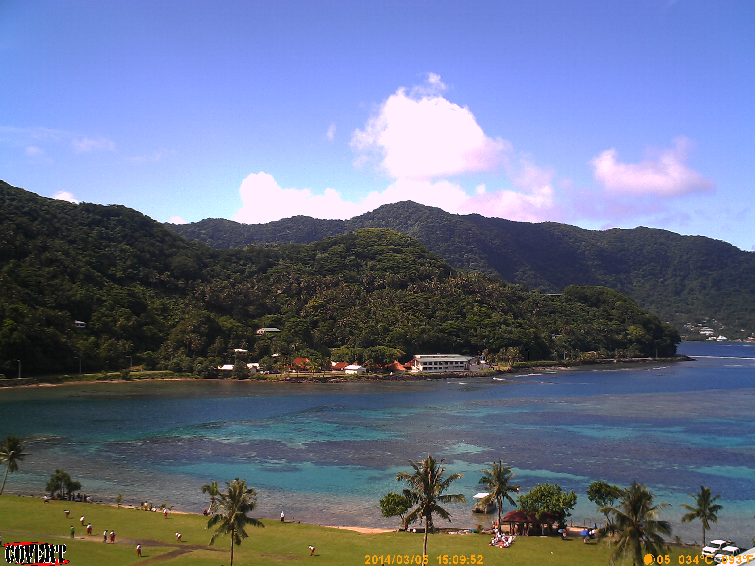

Figure 2. Image of the embayment on a typical, rain-free day. The darker areas of the bay are live coral, and the light areas are deeper pools with carbonate sand bottom.

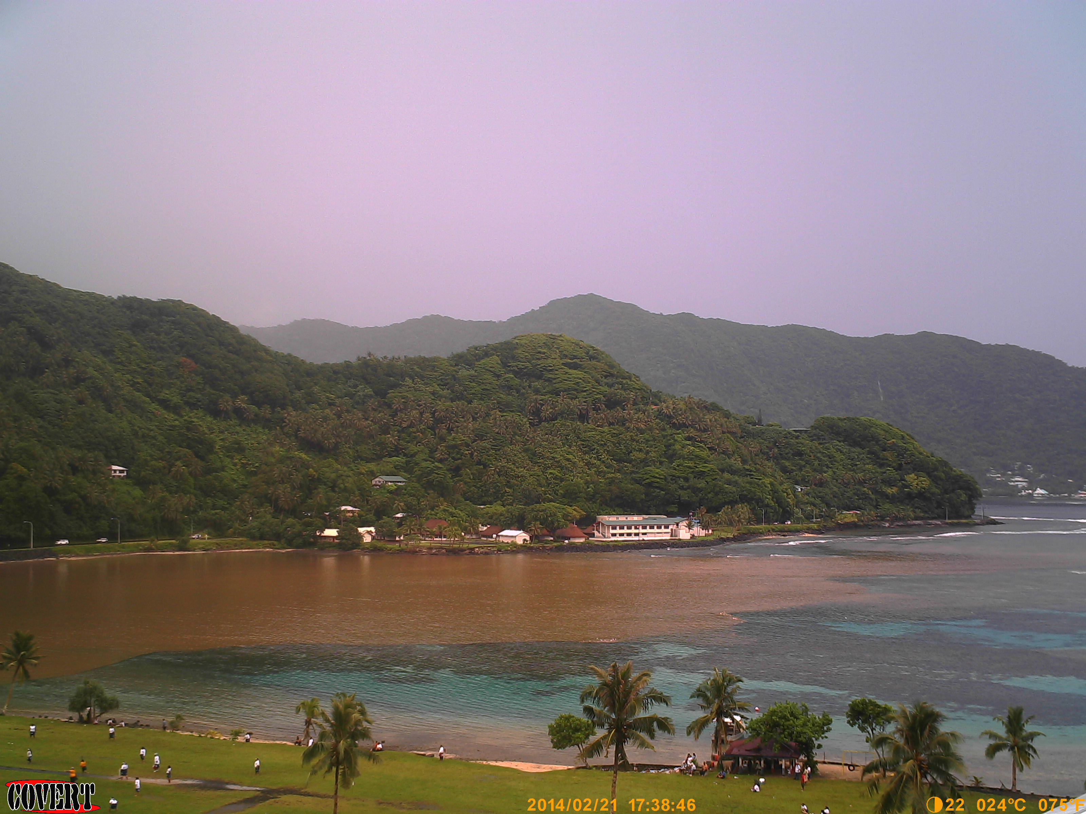

Figure 3. Image of a flood plume (2/21/14) in the northern portion of the bay following a heavy precipitation event. Plumes usually persist for several hours, and rarely are seen after 24h due to the flushing of water through the deep channel and out to sea.



Figure 4. TOP: Images of the shallow-water drifters on land, and deployed in the field. BOTTOM: Images of the acoustic current profilers deployed on the southern reef flat (AS1).

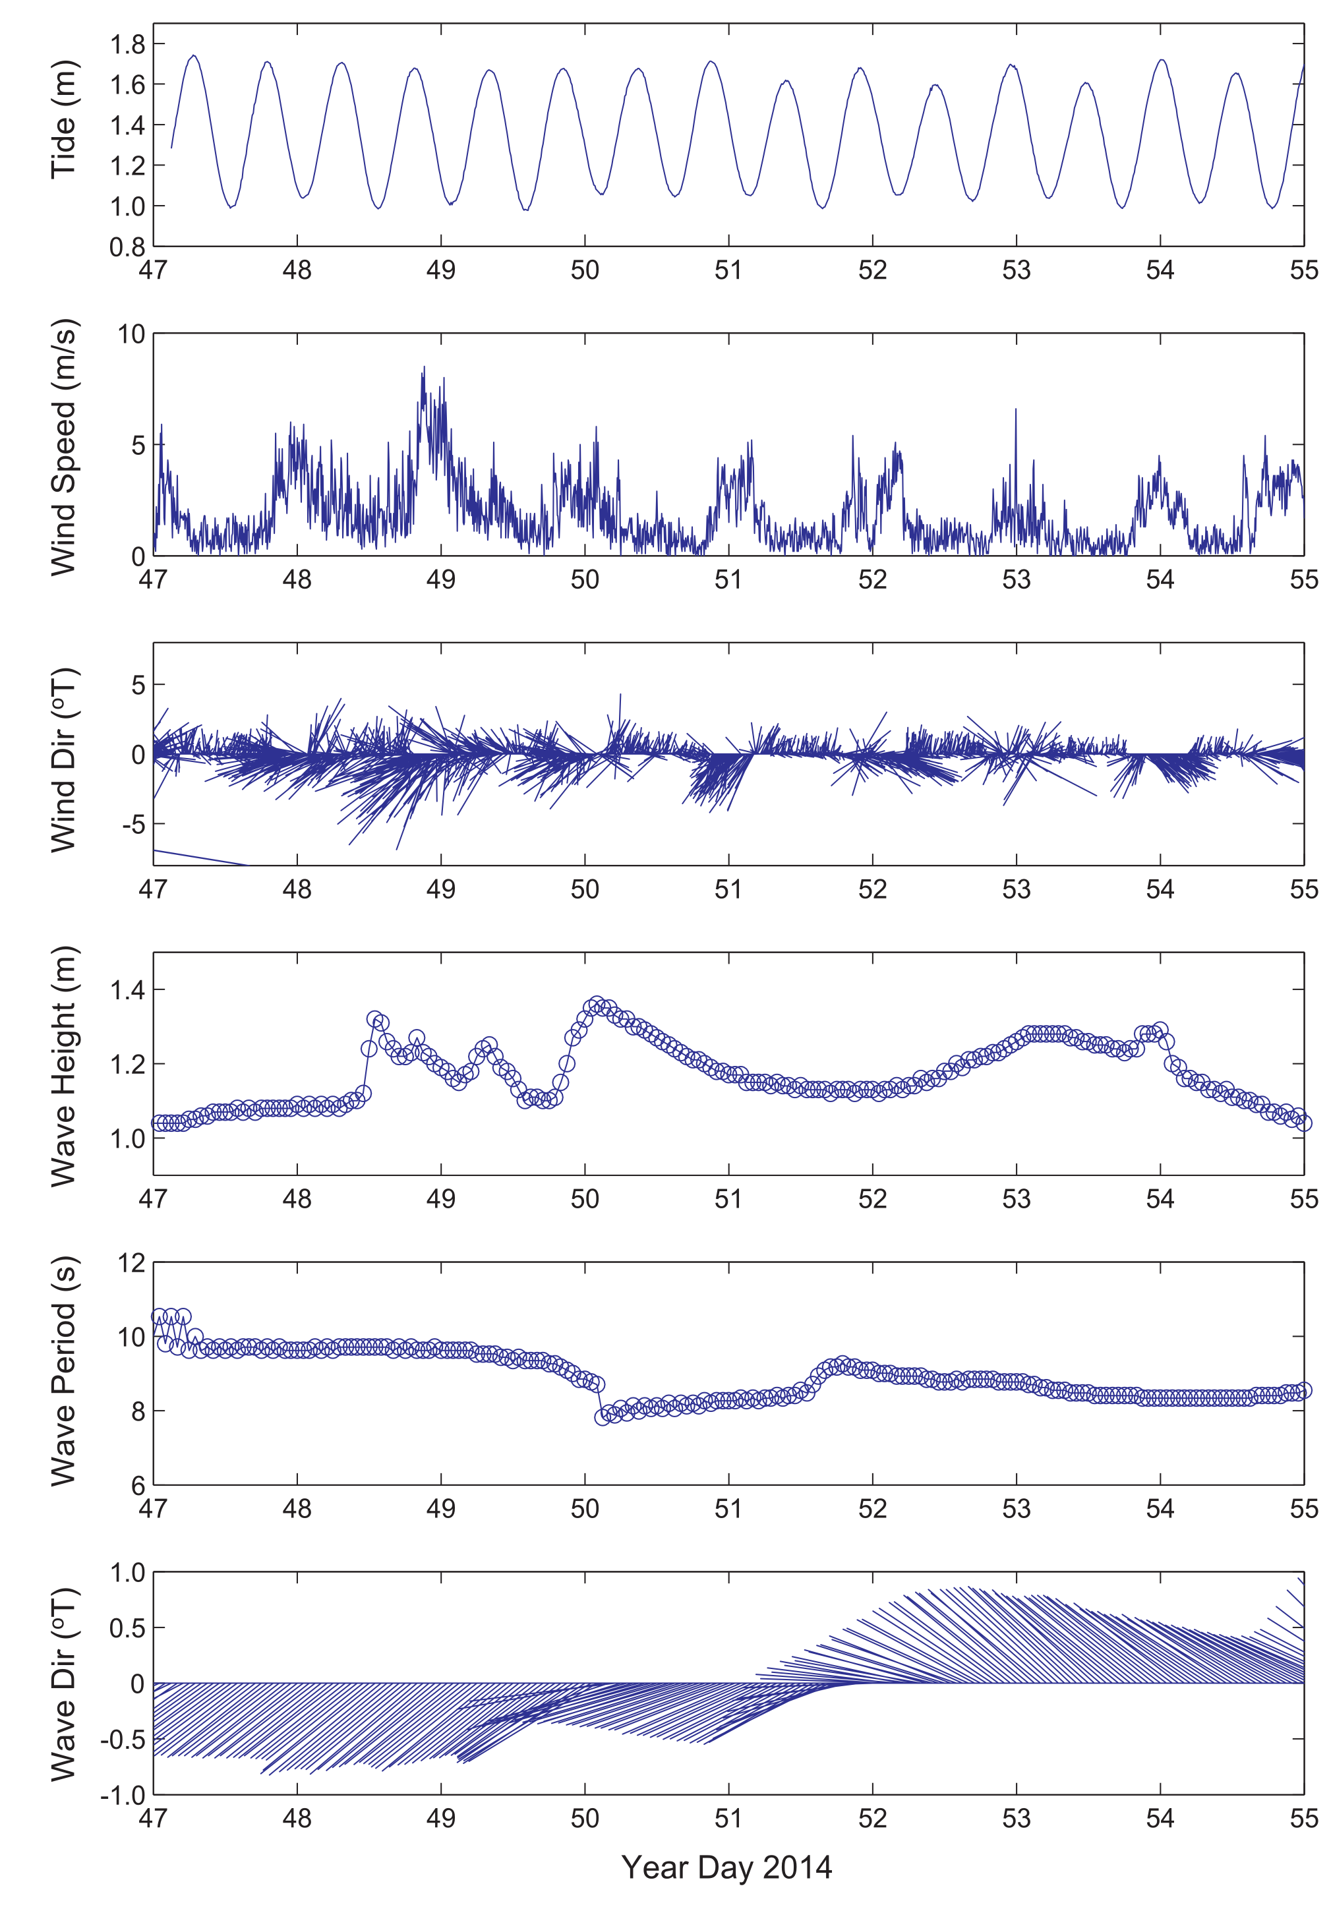

Figure 5. Time series of physical forcing: Tide stage, wind speed, wind direction from NDBC station NSTP6, wave height and direction from NOAA WW3. Day 47=16 Feb 2014, Day 54=23 Feb 2014.

|  |  |  |  |
| --- | --- | --- | --- |
| Table 1. End member periods | | | |
| End member | Julian Day | Gregorian Day (UTC) | Gregorian Day (Local) |
| Tide/Calm | 50-51 | 2/19-2/20 | 2/18-2/19 |
| Wind | 47-49 | 2/16-2/18 | 2/15-2/17 |
| Wave | 52-55 | 2/21-2/24 | 2/20-2/23 |

**Note: Local time is UTC-11 so local dates are actually one day earlier (e.g. Tide=2/18-2/19 Local time)

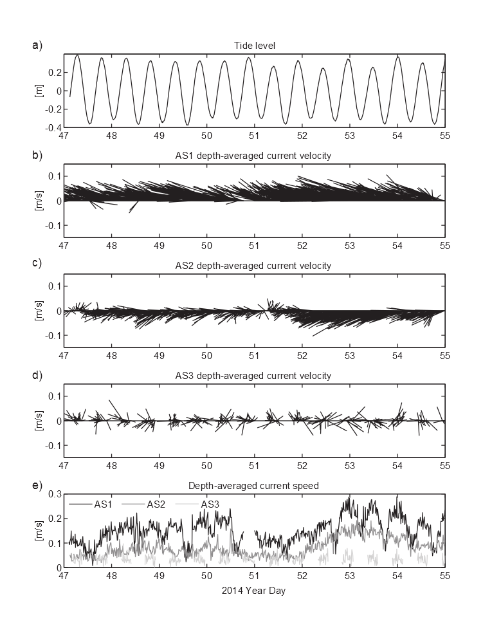

Figure 6. Time series of the resulting flow measured by the acoustic current profilers. Water depths at low tide were too shallow to measure flow data at AS3. Note the variations in current speeds both in space and time due to the different forcing conditions.

|  |  |  |  |  |  |  |  |  |  |  |  |  |  |
| --- | --- | --- | --- | --- | --- | --- | --- | --- | --- | --- | --- | --- | --- |
| Table 2. Drifter deployment dates and conditions. Red numbered Deployments coincide with ADCP deployment | | | | | | | | | | | | | |
| Deployment | Julian(local) | Date | Start Time | End Time | Tide Start | Tide End | Tide movement | Tide | Wind Speed Avg | Wind Direction Avg | Wind Gust Max | Wave Height(m) | Wave Period |
| 1 | 19 | 01/19/2014 | 1300 | 1500 | 1.5 | 1.0 | -0.6 | falling | 1.2 | 232.0 | 4.0 | 0-1 | nan |
| 2 | 20 | 01/20/2014 | 1615 | 1730 | 1.0 | 1.2 | 0.2 | rising | 2.4 | 194.0 | 7.0 | 1-2 | nan |
| 3 | 20 | 01/20/2014 | 1750 | 1900 | 1.2 | 1.9 | 0.7 | rising | 3.2 | 258.0 | 10.0 | 1-2 | nan |
| 4 | 32 | 02/01/2014 | 900 | 1100 | 3.7 | 2.6 | -1.2 | falling | 5.3 | 96.0 | 11.0 | 0-1 | nan |
| 5 | 32 | 02/01/2014 | 1130 | 1300 | 2.2 | 0.9 | -1.3 | falling | 5.7 | 100.0 | 13.0 | 0-1 | nan |
| 6 | 32 | 02/01/2014 | 1700 | 1900 | 1.5 | 3.2 | 1.7 | rising | 4.2 | 188.0 | 13.0 | 0-1 | nan |
| 7 | 39 | 02/08/2014 | 1415 | 1545 | 3.1 | 3.4 | 0.4 | rising | 5.2 | 140.0 | 18.0 | 2-4 | nan |
| 8 | 39 | 02/08/2014 | 1605 | 1800 | 3.3 | 2.5 | -0.8 | falling | 6.0 | 144.0 | 20.0 | 2-4 | nan |
| 9 | 47 | 02/16/2014 | 1654 | 1846 | 2.4 | 3.2 | 0.9 | rising | 3.2 | 169.0 | 9.0 | 0-2 | nan |
| 10 | 48 | 02/17/2014 | 1245 | 1500 | 1.6 | 1.1 | -0.5 | falling | 9.7 | 80.0 | 28.0 | 2-4 | nan |
| 11 | 48 | 02/17/2014 | 1530 | 1700 | 1.1 | 1.6 | 0.5 | rising | 5.9 | 101.0 | 20.0 | 2-4 | nan |
| 12 | 48 | 02/17/2014 | 1710 | 1840 | 1.6 | 2.6 | 0.9 | rising | 5.2 | 90.0 | 15.0 | 2-4 | nan |
| 13 | 49 | 02/18/2014 | 1245 | 1445 | 2.1 | 1.3 | -0.8 | falling | 4.9 | 98.0 | 14.0 | 2-4 | nan |
| 14 | 49 | 02/18/2014 | 1445 | 1700 | 1.3 | 1.4 | 0.1 | low | 4.7 | 194.0 | 15.0 | 2-4 | nan |
| 15 | 50 | 02/19/2014 | 1205 | 1440 | 2.9 | 1.5 | -1.4 | falling | 5.8 | 40.0 | 11.0 | 2-4 | nan |
| 16 | 50 | 02/19/2014 | 1445 | 1720 | 1.5 | 1.2 | -0.3 | falling | 6.6 | 54.0 | 15.0 | 2-4 | nan |
| 17 | 51 | 02/20/2014 | 840 | 1045 | 2.5 | 3.2 | 0.6 | rising | 4.8 | 290.0 | 13.0 | 0-2 | nan |
| 18 | 51 | 02/20/2014 | 1100 | 1200 | 3.2 | 3.0 | -0.2 | falling | 4.3 | 117.0 | 11.0 | 0-2 | nan |
| 19 | 51 | 02/20/2014 | 1210 | 1430 | 3.0 | 2.1 | -1.0 | falling | 3.0 | 238.0 | 12.0 | 0-2 | nan |
| 20 | 51 | 02/20/2014 | 1500 | 1630 | 1.8 | 1.3 | -0.6 | falling | 5.9 | 290.0 | 13.0 | 0-2 | nan |
| 21 | 52 | 02/21/2014 | 920 | 1040 | 2.4 | 3.0 | 0.6 | rising | 2.9 | 253.0 | 11.0 | 4-6 | nan |
| 22 | 52 | 02/21/2014 | 1040 | 1145 | 3.0 | 3.3 | 0.3 | rising | 3.8 | 111.0 | 11.0 | 4-6 | nan |
| 23 | 52 | 02/21/2014 | 1300 | 1400 | 3.2 | 3.0 | -0.3 | falling | 3.0 | 193.0 | 16.0 | 4-6 | nan |
| 24 | 52 | 02/21/2014 | 1500 | 1550 | 2.4 | 1.9 | -0.5 | falling | 3.7 | 152.0 | 11.0 | 4-6 | nan |
| 25 | 53 | 02/22/2014 | 1100 | 1215 | 2.7 | 3.2 | 0.5 | rising | 5.5 | 314.0 | 14.0 | 4-6 | nan |
| 26 | 53 | 02/22/2014 | 1220 | 1315 | 3.2 | 3.4 | 0.2 | rising | 6.3 | 302.0 | 12.0 | 4-6 | nan |
| 27 | 53 | 02/22/2014 | 1600 | 1700 | 2.4 | 1.9 | -0.5 | falling | 4.2 | 311.0 | 10.0 | 4-6 | nan |
| 28 | 53 | 02/22/2014 | 1700 | 1845 | 1.9 | 1.2 | -0.7 | falling | 2.0 | 242.0 | 10.0 | 4-6 | nan |
| 29 | 54 | 02/23/2014 | 1040 | 1210 | 2.0 | 2.9 | 0.9 | rising | 7.2 | 304.0 | 15.0 | 2-4 | nan |
| 30 | 54 | 02/23/2014 | 1210 | 1255 | 2.9 | 3.3 | 0.4 | rising | 5.3 | 260.0 | 11.0 | 2-4 | nan |

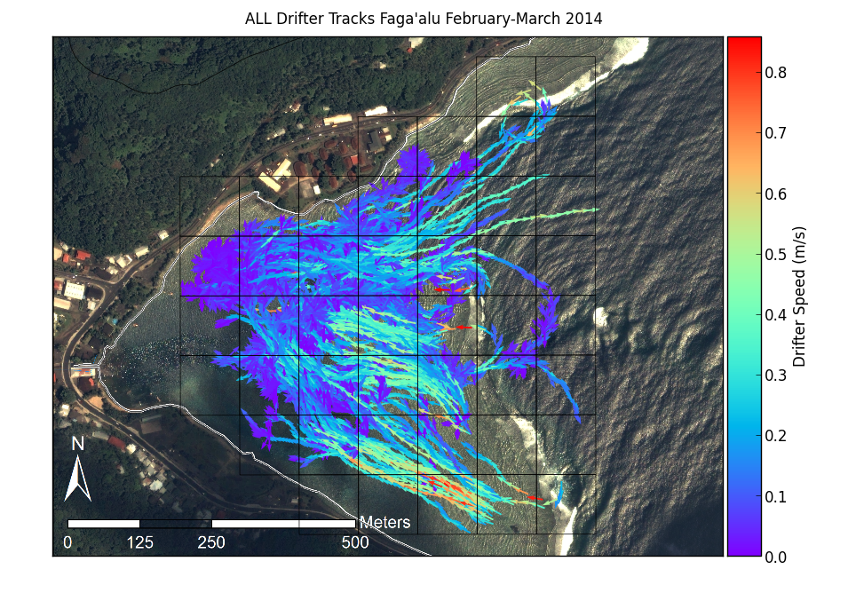

Figure 7. Map of all drifter tracks, colored by speed, recorded during the experiment.

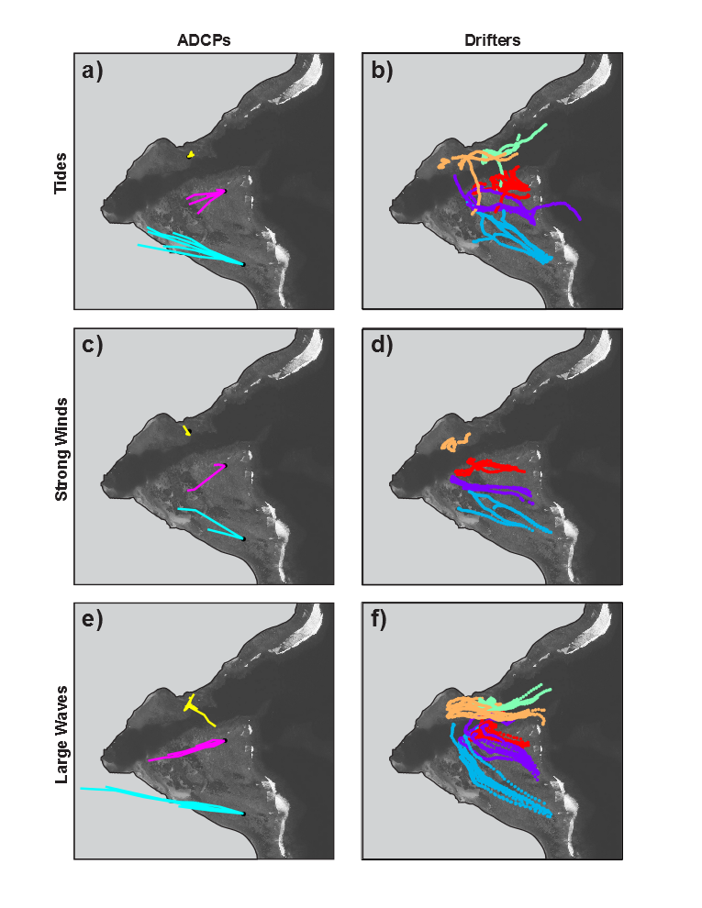

Figure 8. Progressive vectors calculated from ADCP data, compared to actual Lagrangian drifter tracks under different forcing conditions.

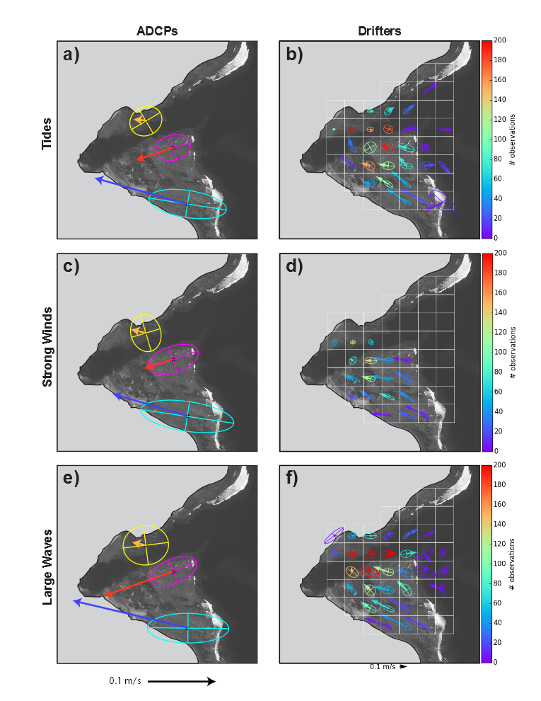

Figure 9. EOF's calculated from ADCP data, compared to EOF's calculated from spatially binned (100m x 100m grid cell) Lagrangian drifter data under different forcing conditions. Drifter EOF's are colored by number of observations to illustrate varying data density depending on grid cell.

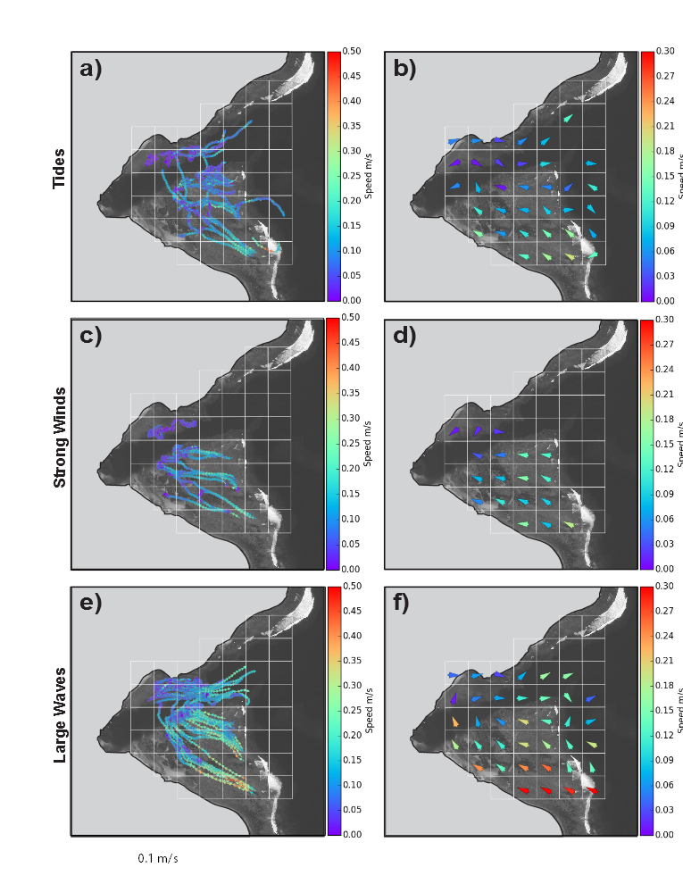

Figure 10. Drifter tracks and calculated mean velocity, colored by speed for different forcing conditions. Cells with no drifter observations are left empty.

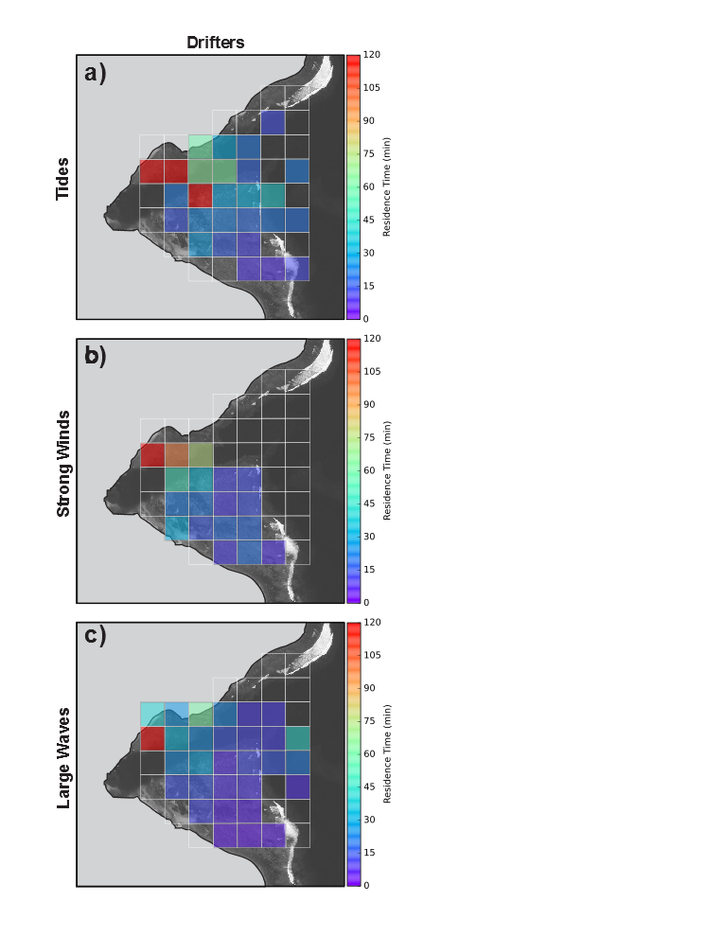

Figure 11. Residence time calculated from mean velocity of drifters under endmember conditions